Information Modeling in OGSA
Architecture Paper

Status of This Document
This document provides information to the Grid community on the direction for information modeling of OGSA resources. It does not define any standards or technical recommendations. Distribution is unlimited.
Copyright Notice
Copyright © Global Grid Forum (2006). All Rights Reserved.
Trademarks
OGSA is a trademark of the Global Grid Forum.

Abstract
Resources in the grid need to advertise their capabilities and activities in the grid need to consume those resources. This architecture paper defines the way to model resources’ capabilities and requirements in the OGSA. It builds on the wealth of existing systems management information already modeled and instantiated in systems today. Examples are included.

Contents

1. Introduction 3
2. Notational Conventions 3
3. Model for OGSA Resources 3
4. Example 5
4.1 Systems management instance information 5
4.2 Advertised Capabilities 6
4.3 Activity Requirements 7
4.4 Matching requirements with advertised capabilities 7
4.5 XML 7
4.6 UML 10
5. OGSA Information Model Architecture 10
5.1 The concrete model architecture and relationship 10
5.2 Representation of resource capabilities 10
5.3 Representation of requirements 11
5.4 Basic set of resource capabilities and properties 12
6. Security Considerations 12
7. Contributors 12
8. Glossary 12
9. Intellectual Property Statement 12
10. Disclaimer 12
11. Full Copyright Notice 12
12. References 13

Introduction
Resources in the grid need to advertise their capabilities and activities in the grid need to consume those resources. This architecture paper defines the way to model resources’ capabilities and requirements in an OGSA environment. It builds on the wealth of existing systems management information already modeled and instantiated in systems today. Examples are included.

Notational Conventions
The key words ‘MUST,” “MUST NOT,” “REQUIRED,” “SHALL,” “SHALL NOT,” “SHOULD,” “SHOULD NOT,” “RECOMMENDED,” “MAY,” and “OPTIONAL” are to be interpreted as described in RFC 2119 [BRADNER1].

Model for OGSA Resources
Resources are typically modeled for three reasons: (1) to manage resource information in the system, (2) to advertise the capabilities of resources in the system, and (3) to express a set of requirements such as those needed by a job that is to run in the system.
Today, a system’s resources are typically modeled so systems (including network) management applications can manage (provision, configure, manage, and de-provision) those resources. Information modeled for systems management applications tends to be very granular and detailed. Examples of models of managed information are GLUE and CIM. Examples of managed information are:
- The processor(s) for each computer with attributes like ProcessorFamily, Version, MaxClockSpeed, CurrentClockSpeed, DataWidth, AddressWidth, Load, CPUStatus, ExternalBusClockSpeed.
- The operating system for each computer (node) and processor with attributes like OSType, Version, LastBootUpTime, LocalDateTime, CurrentTimeZone, NumberOfProcesses, MaxNumberOfProcesses, MaxProcessesPerUser, TotalSwapSpaceSize, TotalVirtualMemorySize, FreeVirtualMemory, FreePhysicalMemory.
- Each computer (node) with attributes like Name and NameFormat (e.g. DNS style hostname), Load.
- Relationships between elements of the above information to express, for example, that a given computer has n processors, has 1 or more installed operating systems, and one of those installed operating systems is actually the running operating system.
- Values of attributes are typically discrete values and specific
Figure 1 depicts this usage from both the ‘manage’ and the ‘use’ points of view.
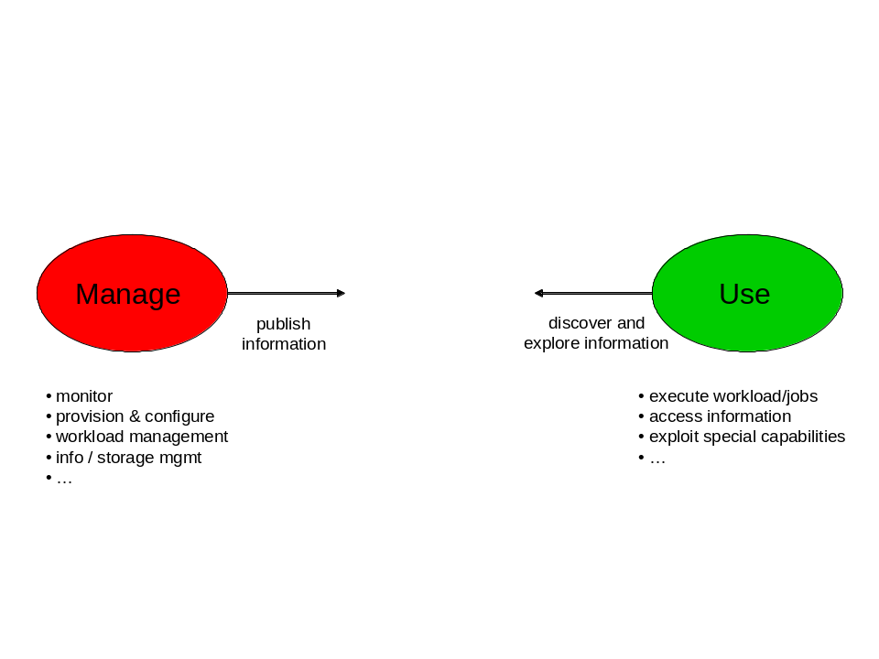
Figure 1. Resource Usage
In the Grid, jobs (or in the more general sense – activities) need to run where its resource requirements are satisfied or can be provisioned to satisfy those requirements. To make that determination, systems in the grid need to advertise the capabilities of its resources. Activities that are run in the grid may be parallelized applications and run on multiple nodes in the grid. So requirements may need to be expressed for multiple resources of the same type (e.g. Activity A needs a minimum of three processors with n CPU seconds (or m seconds of wall clock time) available) as well as total CPU seconds or wall clock time for that activity. Therefore, these requirements and capabilities need to be expressed in terms that are meaningful to the activity’s writer (e.g. user friendly). Values may be discrete or may be a range of values.
A study of the way in which managed information is modeled for systems management and how resources are modeled in the Grid to express requirements and capabilities leads one to conclude that the systems management type of model for information modeling of resources is not what’s needed in the OGSA. Instead, a higher level, less granular, and more user friendly information model is needed to express an activity’s requirements and to advertise a resource’s capabilities. However, since managed information exists in systems today, it is beneficial to determine a resource’s advertised capabilities from that existing managed information. Figure 2 proposes the relationship between a system’s managed information and a Grid’s need to advertise resource capabilities and an activity’s requirements to consume resources.
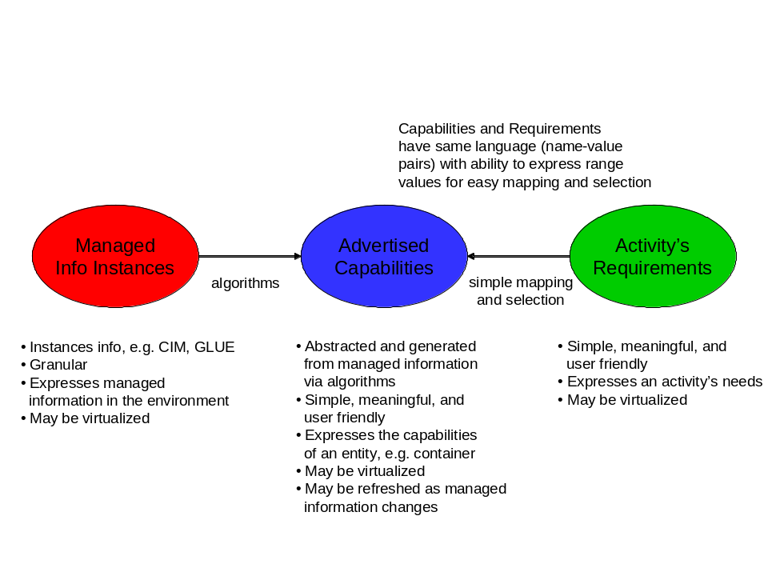
Figure 2. OGSA Information Model Concept
Capabilities are abstracted and generated from managed information via algorithms. These capabilities are updated as the managed information in the system changes. An activity’s requirements are mapped against the advertised capabilities to determine which resources it will consume and hence where that activity can execute. These capabilities and requirements have the same language for simple mapping and selection of resources. The language is expressed in XML as name-value pairs where values can be expressed as ranges as well as discrete values.
There are two categories of capabilities that can be advertised. The first category is capabilities that are typically consumed by an activity such as an application – the activity’s requirements are expressed in a JSDL document. These capabilities typically have static values, e.g. total physical memory or operating system type. The second category is capabilities that are typically consumed by some system component such as a job manager. These capabilities may be static or may change as activities are executed, e.g. available physical memory, load.

Example
This example shows the managed information in a system, the capabilities advertised from that system that an activity can consume, and the activity’s requirements that are matched against the advertised capabilities. In this example, the activity is some application with a JSDL document, and the capabilities advertised are those that may be typically matched against a JSDL document. Capabilities that a system component may want to consume are not advertised in this example.

Systems management instance information
The system management information consists of the following:
Computer A has DNS-style hostname, Name=computerA.acme.com. It is classified as a non-dedicated system (ability to run applications, store data, act as a router or gateway, etc) with attribute Dedicated=0. Likewise, Computer C has a DNS-style hostname, Name-computerC.acme.com and the same characteristics as Computer A.
Computer B has DNS-style hostname, Name=computerB.acme.com. It is classified as a router with attribute Dedicated=4.
Computer A has 1 processor and Computer C has 2 processors. Each processor instance has the following managed information:
- ProcessorFamily=118 (AMD Athlon 64) for Computer C and ProcessorFamily=185 (Intel Pentium M) for Computer A
- UpgradeMethod=16 (Socket 754)
- MaxClockSpeed=3200 MHz
- CurrentClockSpeed=3000 MHz
- DataWidth=8 bit
- AddressWidth=32 bit
- Load=50% (Computer A – processor 1), Load=73% (Computer C – processor 1), Load=30% (Computer C – processor 2)
- Version=3.1.c
- ID=975403-2 (Computer A – processor 1), ID=984567-3 (Computer C – processor 1), ID=967021-8 (Computer C – processor 2)
- CPUStatus=1 (CPU enabled)
- ExternalBusClockSpeed=800 MHz (front side bus)
- Characteristics=2 (64 bit capable)
Computers A and C each have operating systems Windows XP Service Pack 2 and Linux installed. Computers A and C are currently configured and running the Linux operating system. Managed information for the current running Linux operating system is:
- OSType=36 (Linux)
- Version=2.1.f (major.minor.revision)
- LastBootUpTime=20060501
- CurrentTimeZone=-6 (CentralUS)
- NumberOfUsers=4
- NumberOfProcesses=67
- MaxNumberOfProcesses=0 (no maximum)
- TotalVirtualMemorySize=amt of total RAM + amt of paging space (SizeStoredInPagingFiles)=12000000 KB
- FreeVirtualMemory=amt of free RAM + amt of free paging space (FreePhysicalMemory + FreeSpaceInPagingFiles)=4100000 KB
- FreePhysicalMemory=100000 KB
- TotalVisibleMemorySize (amount of physical memory allocated to this OS)=4000000 KB (4GB)
- SizeStoredInPagingFiles=8000000 KB
- FreeSpaceInPagingFiles=4000000 KB
- MaxProcessMemorySize (max bytes allocated to a process)=1500000 KB
- MaxProcessesPerUser=32
Computer B has 1 processor of type Intel running Windows XP operating system. The details for Computer B are not stated here because that computer is classified as a router and will not run activities. So for this example, the advertised capabilities are minimal (in reality, it does advertise more than the minimal capabilities listed in this example).
Some values of this managed information are static for the life of the instance (e.g. hostname, operating system type), and some values change over time (e.g. processor load, free memory (physical, virtual, page space)).
This instance managed information will not be presented in XML in this example because different models have different XML representations. The representation of this managed information is not the focus of this position paper – what matters in this example is that this managed information exists and can be used to generate a resource’s advertised capabilities.

Advertised Capabilities
Computers A and C advertise their capabilities as a stated below. These capabilities are algorithmic generated from granular detailed managed information. Some capabilities may map one-to-one with the managed information, e.g. CPUSpeed is the same as MaxClockSpeed (only a difference in name for usability, in this case; in other cases the name may be preserved). Some capabilities are computed from one or more pieces of managed information, e.g. PhysicalMemory for a machine with 2 processors that is advertised as available for 1 or more activities is the computation (TotalVisibleMemorySize for processor 1 + TotalVisibleMemorySize for processor 2).
Computer B is dedicated to routing and will not execute work (activities). Computers A and C can execute work (activities) because there is not advertised work restriction.

- Hostname=computerA.acme.com
- Processor
- Type=Intel
- CPUSpeed=3200
- OS=Linux
- PhysicalMemory=3000000
- VirtualMemory=12000000
- MaxProcessesPerUser=32

- Hostname=computerC.acme.com
- Processor
- CPUCount=2
- Type=AMD
- CPUSpeed=3200
- OS=Linux
- PhysicalMemory=3000000
- VirtualMemory=12000000
- MaxProcessesPerUser=32

Computer B advertises (minimally for brevity in this example) its capabilities as:
- Hostname=computerB.acme.com
- Dedicated=router
- Processor
- Type=Intel
- OS=WindowsXP
- PhysicalMemory=8000000
- VirtualMemory=20000000

Activity Requirements
Activities 1 and 2 list their resource requirements needed to execute. These resource requirements are mapped against advertised capabilities to determine which resources this activity will consume and hence where the job will run.

- Activity1
- Processor=AMD or Intel
- CPUSpeed >2500 and <3500
- OS=Linux
- PhysicalMemory=2000000

- Activity2
- Processor=Intel
- CPUCount<=2
- CPUSpeed>3000
- OS=WindowsXP

Matching requirements with advertised capabilities
A system component, such as a job manager, will match an activity’s requirements against resources’ advertised capabilities to determine the possible place(s) that activity may execute.
Activity 1 can execute on either Computer A or Computer C.
Activity 2 can execute on Computer A if that computer is re-provisioned to run the WindowsXP operating system.

OGSA Information Model Architecture
To move from the concept described above to a concrete architecture (and implementation), the following items form the architecture or pattern.
- Relationship to systems management (detailed) model: described in the above picture
- A concrete advertisement / requirement model: based on Condor class-ads
- Representation of resource capabilities: a simple XML document format
- Representation of requirements: a usable subset of XQuery
- Basic set of resource capabilities and properties from which to extend

The concrete model architecture and relationship
Figure 3 shows the concrete OGSA information model architecture and its relationship to systems management models.
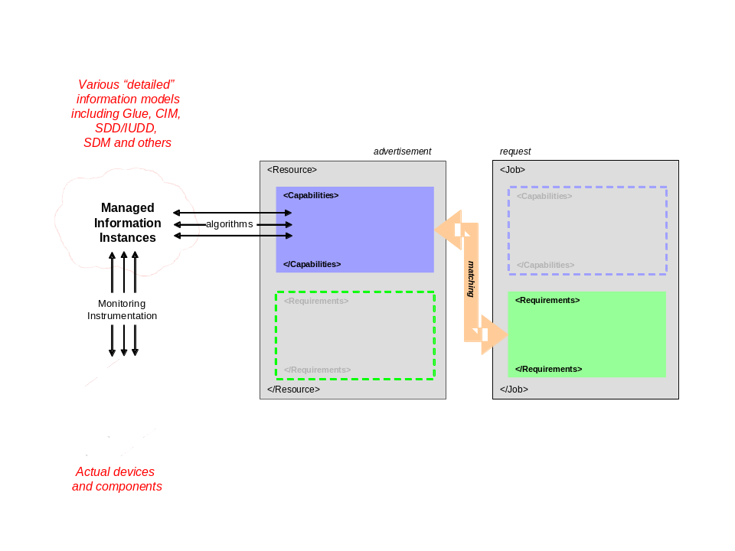
Figure 3. OGSA Information Model Architecture
Resources advertise capabilities – physical, logical, and generated. These capabilities are abstracted from detailed systems management information via algorithms. Some capabilities are static, others are dynamic. Those that are dynamic are refreshed as their values change or are created/deleted per their lifespan. Jobs (or activities) specify their requirements and are matched against capabilities resources advertise to determine placement, execution, etc.
Taking this one step further, resources also have a need to express requirements (e.g. policy) and jobs (or activities) also have a need to express capabilities (e.g. identity). The concrete model allows for this symmetry as shown in Figure 4. It is recognized that there are specifications in place for things like policies and identification – this architecture is not meant to replace any of those specifications but rather to note that policy and identification are an integral part of the concrete model and further investigation needs to occur to understand how best to convey that information with respect to resources and jobs (or activities).
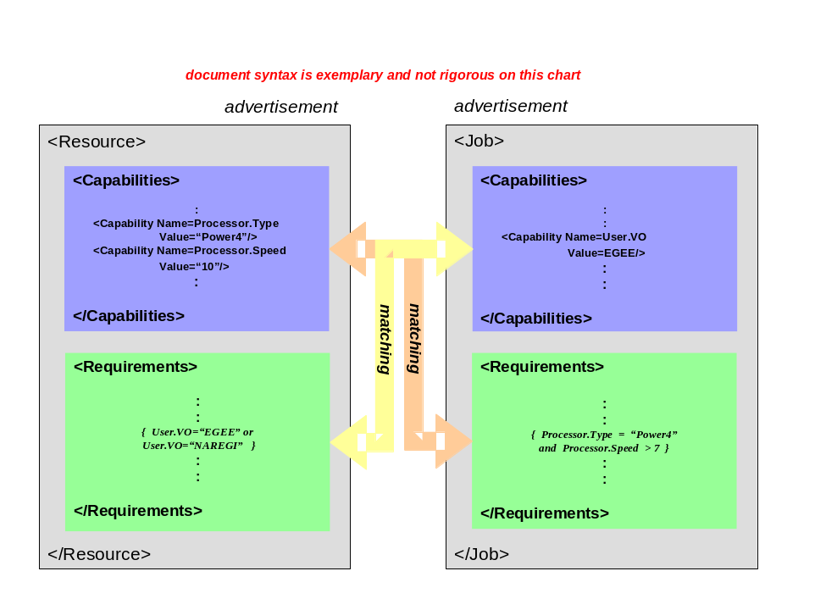
Figure 4. Advertisement-Requirement Matching

Representation of resource capabilities
Resource capabilities are represented in one or more XML documents. This provides the user/developer/tooling a declarative format. Capabilities are expressed as name-value pairs, that is, capability is a name and property is its value. Most capabilities can be expressed in a 2 level hierarchy for simplicity, although the hierarchy is not limited to 2 levels. The XML document can either be stored natively (as XML document) or in a relational table (nice for searching and matching). Most database systems today support XML document to relational table conversion. The concrete rendering uses XSD schema and XML typing. In XML typing, reuse of element names requirements use of namespaces. The <any> construct is used for extensibility in XSD. Extensions can be derived from existing models and the OGSA basic resources. And existing XML models can be included in the XML document. Because typing an XML document can be tedious and error-prone, this representation and its characteristics for resource capabilities was chosen to capitalize on existing tooling for generation and validation to quickly seed adoption.
Figure 5 is an example of rendering a few resources (physical) in this representation. Logical and generated resources also use this rendering. Two important aspects of the rendering are semantics and abstracted usable properties. For example, the CPU speed varies by vendor. From the user’s point of view, he is more interested in a relative abstracted value rather than having to figure out how to identify which processors from different vendors satisfy his speed requirements. Hence, there is a defined semantic associated with the value ‘10’ of property ‘Speed’. These types of abstractions and semantics are documented as part of the model, ideally as part of the defined resource capabilities. Likewise, any algorithm used to generate this abstracted capability is documented as part of the model.
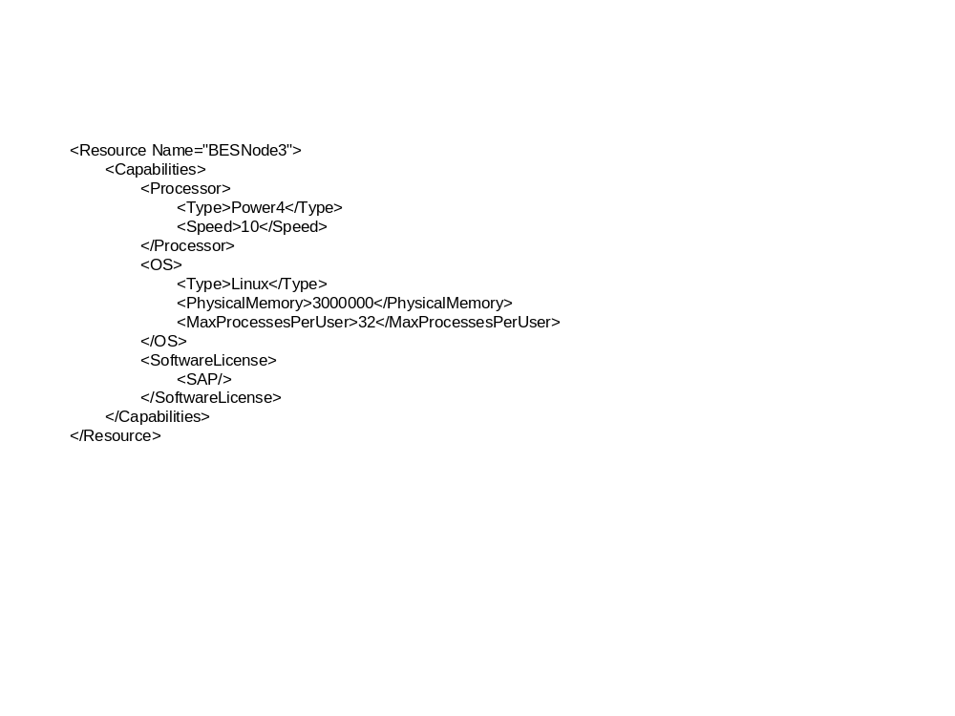
Figure 5. Resource Capabilities XML Rendering Example

Table 1 shows the resource capabilities from Figure 5 stored in a relational table.

Resource | Capability | Property | Value
BESNode3 | Processor | Type | Power4
BESNode3 | Processor | Speed | 10
BESNode3 | OS | Type | Linux
BESNode3 | OS | PhysicalMemory | 3000000
BESNode3 | OS | MaxProcessesPerUser | 32
BESNode3 | SoftwareLicense | SAP | 1 (True)
Table 1. Resource Capabilities Relational Table Rendering Example

Representation of requirements
A job’s or activity’s requirements are expressed using XQuery. The XQuery language is a fairly complete algebra with many comparison and arithmetic operators that are needed to express requirements both as single values and ranges of values. User defined function and prologues can be exploited to use of XQuery specified requirements simpler to write. Implementation of a resource repository to hold a job’s or activity’s requirements may be either a native XML document store or a database. These queries work again XML documents – those documents that express resource capabilities. Because typing an XML document of XQueries can be tedious and error-prone, this representation and its characteristics for specifying requirements was chosen to capitalize on existing tooling for generation and validation to quickly seed adoption.
Since XQuery is really an XML programming language, a profile of XQuery will be defined to restrict its usage to a reasonable and usable subset for expressing requirements.
This is an example of requirements specified using XQuery.
<insert example TBD>

Basic set of resource capabilities and properties
This basic set of resources is VERY PRELIMINARY and will be further specified in the Sep/Oct 2006 timeframe by the following OGF workgroups / design team: Basic Execution Service(BES) WG, Job Submission Description Language (JSDL) WG, High Performance Computing profile (OGSA) design team. Table 2 represents the author’s view of the consolidated needs from GLUE, JSDL, CIM, GIN, and NAREGI at the advertisement/requirements level.

Capabilities | Properties
Service | TBD
VO | TBD
Host | TBD
Cluster | TBD
OperatingSystem | TBD
Processor | TBD
Memory | TBD
StorageElement | TBD
FileSystem | TBD
NetworkAdaptor | TBD
ApplicationSoftware | TBD
JobPolicy | TBD
AccessControlPolicy | TBD
Table 2. Basic Set of Resource Capabilities/Properties

Security Considerations
Use of managed information in models is subject to an activity’s authentication and authorization to use those resources. That authentication and authorization is outside the scope of this proposal. It is the responsibility of the security subsystem and protocols.

Contributors
TBD.

Glossary
TBD.

Intellectual Property Statement
The GGF takes no position regarding the validity or scope of any intellectual property or other rights that might be claimed to pertain to the implementation or use of the technology described in this document or the extent to which any license under such rights might or might not be available; neither does it represent that it has made any effort to identify any such rights. Copies of claims of rights made available for publication and any assurances of licenses to be made available, or the result of an attempt made to obtain a general license or permission for the use of such proprietary rights by implementers or users of this specification can be obtained from the GGF Secretariat.
The GGF invites any interested party to bring to its attention any copyrights, patents or patent applications, or other proprietary rights which may cover technology that may be required to practice this recommendation. Please address the information to the GGF Executive Director.

Disclaimer
This document and the information contained herein is provided on an “As Is” basis and the GGF disclaims all warranties, express or implied, including but not limited to any warranty that the use of the information herein will not infringe any rights or any implied warranties of merchantability or fitness for a particular purpose.

Full Copyright Notice
Copyright (C) Global Grid Forum (2006). All Rights Reserved.
This document and translations of it may be copied and furnished to others, and derivative works that comment on or otherwise explain it or assist in its implementation may be prepared, copied, published and distributed, in whole or in part, without restriction of any kind, provided that the above copyright notice and this paragraph are included on all such copies and derivative works. However, this document itself may not be modified in any way, such as by removing the copyright notice or references to the GGF or other organizations, except as needed for the purpose of developing Grid Recommendations in which case the procedures for copyrights defined in the GGF Document process must be followed, or as required to translate it into languages other than English.
The limited permissions granted above are perpetual and will not be revoked by the GGF or its successors or assignees.

References
Note that only permanent documents should be cited as references. Other items, such as Web pages or working groups, should be cited inline (i.e., see the Global Grid Forum, http://www.ggf.org). References should conform to a standard such as used by IEEE/ACM, MLA, Chicago or similar. Include an author, year, title, publisher, place of publication. For online materials, also add a URL.
[BRADNER1] Bradner, S. Key Words for Use in RFCs to Indicate Requirement Levels, RFC 2119. March 1997.

XQuery is based on XPath 2.0. XQuery specification was completed in November, 2005 and is in its 2nd last call currently.

